Interface
Help System 3
Tooltips 3
Help Menu 3
General Web-based Help 3
Scripting Reference 3
Save System Info 3
Info Window Log 4
Splash Screen 5
Interface 5
User Interface Principles 6
Components of an Editor 7
Regions 8
Header 8
Panels 8
Tabs 9
Pinning 9
Input Devices 9
Usage of Mouse Buttons 9
Non English Keyboard 10
The Window System 10
The default scene 10
Arranging Areas 11
Maximizing an Area 11
Splitting an Area 12
Joining Two Areas 12
Changing Area Size 13
Swapping Contents 13
Opening New Windows 13
Window Headers 13
Hiding a header 13
Showing a header 14
Header position 14
Window type button 14
Menus and buttons 14
Collapsing Menus 15
Hiding the editor type menu 15
The Console Window 16
Platform Dependant Instructions 16
Linux 16
Mac OSX 17
MS-Windows 18
Console Window Status and Error Messages 18
Common messages 18
Screens 19
Configuring your Screens 20
Adding a new Screen Type 20
Deleting a Screen 20
Rearranging a Screen 20
Overriding Defaults 20
Additional Layouts 20
Panels 21
Buttons and Controls 22
Operation Buttons 22
Toggle Buttons 22
Toggle Drag 23
Radio Buttons 23
Number Buttons 23
Multi-Value Editing 23
Expressions 24
Expressions as Drivers 24
Units 24
Unit Names 24
Menu Buttons 25
Menu Shortcuts 25
Header Menus 25
Pop-Up Menus 25
Data-Block Menus 26
Extended Controls 27
Color Picker 27
Color Picker Types 28
Hexidecimal Colors 28
Eye Dropper 29
Color Ramp Widget 29
Curve Widget 30
Control Points 30
Controls 31
List View 32
Copy / Paste 32
Undo and Redo 33
Undo 33
Redo 33
Redo Last 33
Undo History 34
Repeat Last 35
Repeat History 35
Screen Capture 35
Screenshots 36
Screencasts 36
Blender Window Dimension 38
Ruler and Protractor 38
Usage 40

Help System

Tooltips
When hovering your cursor over a button or setting, it will show you the Tooltip, and related details depending on the button type, such as the key-shortcut for a tool.
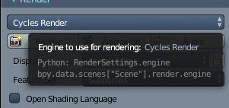The Mouse pointer was Stopped for a while over the Render Engines List in the Info Window.
The Python: text, included last may be of interest to you if you’re an animator or automating tasks, see Scripting & Extending Bforartists.

Help Menu
Bforartists has a range of built-in and web-based Help options.

General Web-based Help

Tip
Browser and Internet Connection
Some forms of Help start up your web browser and access the Bforartists Foundation’s web servers. In order to do this, you must have configured a default web browser for your Operating System, and have a connection to the Internet.

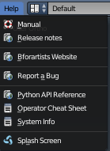
- Manual - which you are now reading.
- Release Notes - The release notes on the Web for the current Bforartists version.
- Bforartists Website - The Bforartists.org home page.
- Report a Bug The Bforartists Bug Tracker.
Note: in order to Report a Bug, you must register at the website.

Scripting Reference
- Python API Reference - Python application programming interface (API).
- Operator Cheat Sheet - Creates the OperatorList.txt text-block, which you can access in the Text Editor. You can also use Bforartists Search to generate the file. The lists the available Python operators.

Save System Info
Access Help ‣ Save System Info
This extracts system information which can be useful to include in bug reports, inspecting the configuration or diagnosing problems.
You will be prompted to save a text file system-info.txt.
The text file contains sections:
Bforartists
This section shows you the Bforartists version, details about the build configuration, and the path in which Bforartists is running.
Python
The Python version you are using, showing the paths of the Python programming language paths.
Directories
Paths used for scripts, data-files, presets and temporary files.
Those directories are configured using the User Preferences Editor Window.
OpenGL
This section shows the OpenGL version, the name of the manufacturer, and lists the capabilities of your hardware & driver.

Info Window Log
This is not exactly a Help menu, but it is related. If you mouse-over the line between the Info window and the 3D then click and drag the Info window down a bit, you can see the stream of Python calls that the UI is making when you work. This can be useful in creating scripts.

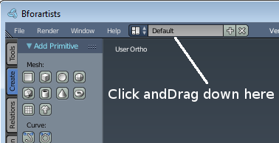
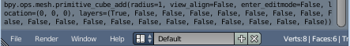
The Info Window Log after adding a Cube

Splash Screen
Usually the splash screen shows at startup until you change this behaviour in the User preference. You can also bring up the Splash screen by clicking on the Splash Screen button in the Help menu. This displays the image where you can identify the current version.
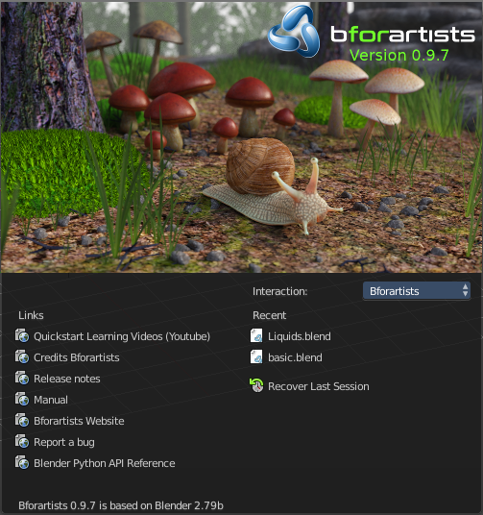
Bforartists Splash Screen
The splash screen contains also a few links to useful resources, like the official Quickstart Learning videos. Or the Python API.
Here you can change the keymap too. The Interaction menu item.
When you install a new version, and start it the first time, then it also provides the Copy Previous settings button. Which will transfer over the settings from the previous Bforartists version.
It displays a way to recover the last session.
And in the last line you can see at which Blender version Bforartists is based.

Interface

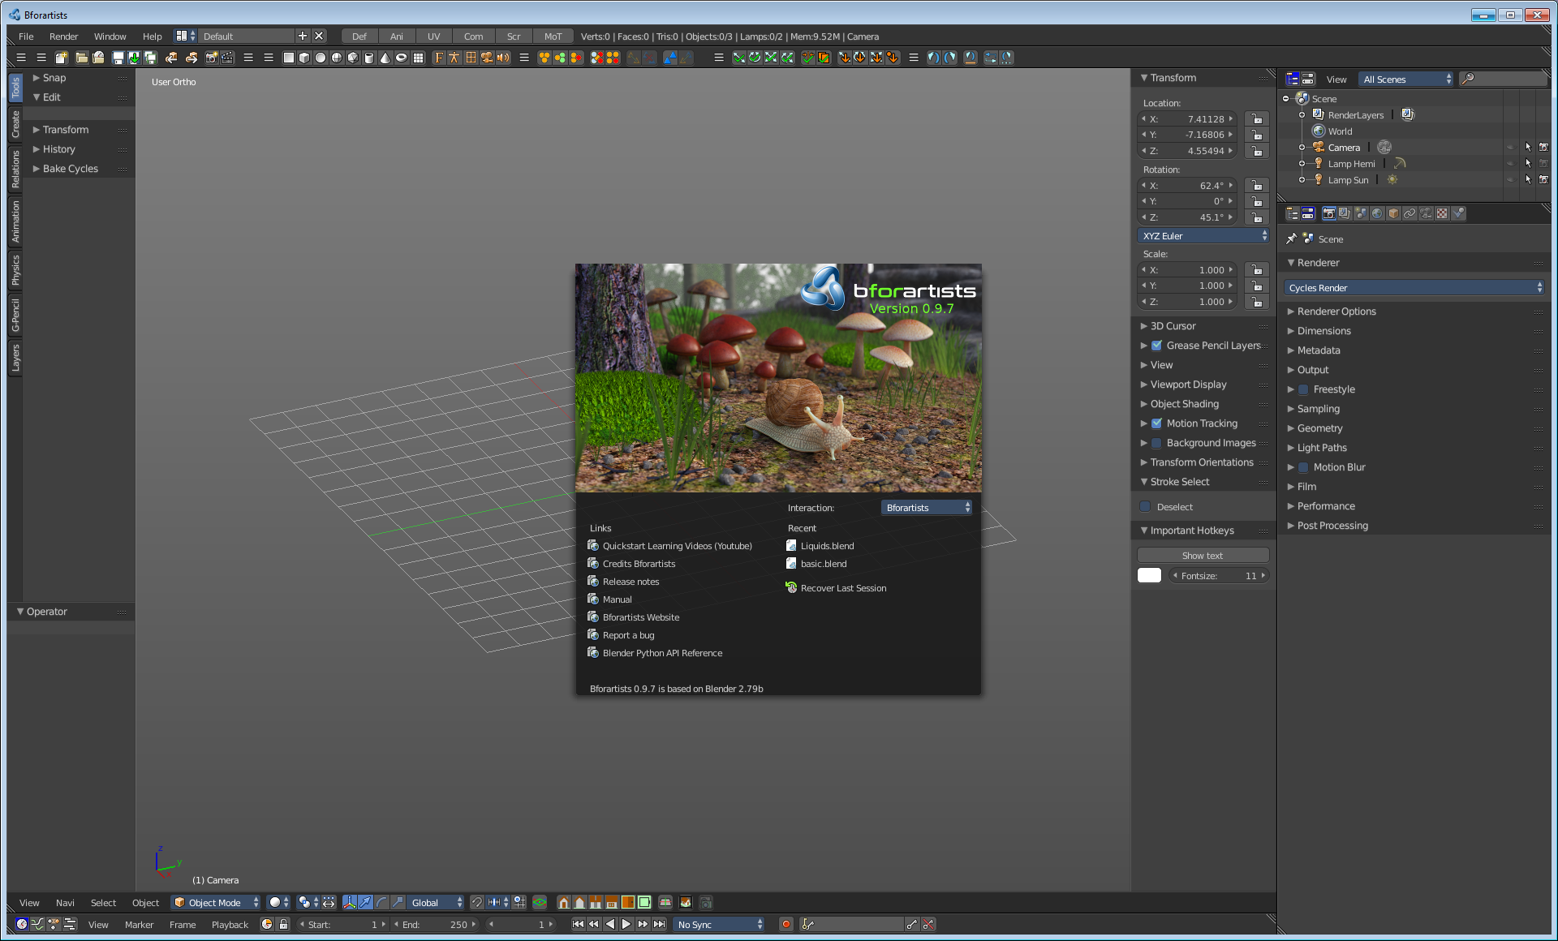
When starting Bforartists, the splash screen appears. On the left side are links to official web pages, and on the right are your most recently opened projects.
To close the splash screen perform an action , like start a new project, press Esc or click anywhere inside the Bforartists Window (except on the splash screen)..

User Interface Principles
Non Overlapping
unlike the original Blender UI where this was just propaganda, the new UI for Bforartists will truely be designed to allow you to view all relevant options and tools at a glance without pushing or dragging editors around. Since all relevant elements will be accessible at top level.

Non Blocking
Tools and interface options will not block the user from any other parts of Bforartists. Bforartists typically doesn’t use pop-up boxes (requiring users to fill in data before running an operation).

Non Modal Tools
Tools can be accessed efficiently without taking time to learn dozens of hotkeys first and without the bend to a wicked UI. You can easily select between different tools by buttons.
Intuitive graphical UI centered useage
Bforartists is based at a intuitive uesage around the graphical UI. This means buttons and widgets. This doesn't exclude hotkeys. But the official Bforartists keymap is reduced to the very basics. And not the primary way to use Bforartists. You will have to add your own hotkeys when you need it.
Note
There is nevertheless still A TON of hotkeys to find in the Input manager. The reason is that the input manager handles all input. Not just the hotkeys from the tools. And some of the navigation can simply not be done without hotkeys.
See also the Bforartists keymap page in the Bforartists in the Manual section of the WIKI

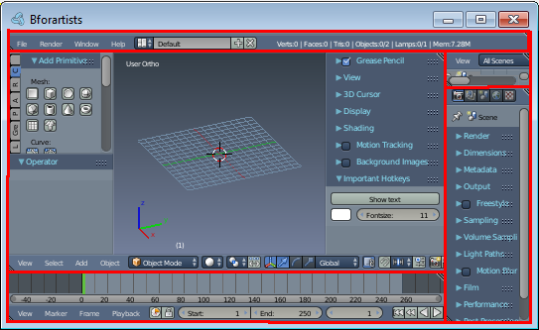
The Bforartists window is organized into one or more Areas with each area containing an Editor. Editors are divided into a Header and one or more Regions. Regions can have smaller structuring elements like panels with buttons, controls and widgets placed within them.
The composition of various Areas with predefined Editors in them is called a Screen Layout. By default Bforartists starts up with a layout of 5 Editors as shown in the image below.

Components of an Editor
In general an editor provides a way to view and modify your work through a specific part of Bforartists.
The image below shows the 3D View as an example of an editor.
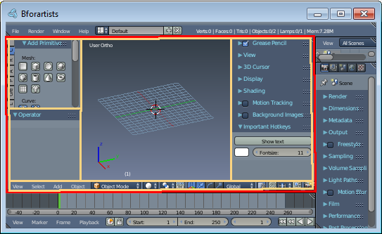
The 3D View
Editors are consistently organized into following parts:

Regions
At least one region of an editor is always visible. It’s called the main region and is the most prominent part of the editor. In the 3D View above this is marked with a green frame.
Aside from that there can be more regions available. In the 3D View above these are the Toolshelf on the left side and the Properties on the right side. Additional regions mostly show context-sensitive content.
Each editor has a specific purpose, so the main region and the availability of additional regions are different between editors. See specific documentation about each editor in the Editors chapter.

Header
A header is a small horizontal part of an editor and sits either at the top or bottom of the area. It acts as a container for menus and commonly used tools. Much like additional regions the header can be hidden.
The 3D View above the header is marked with a purple frame.
See: Headers for details.

Panels
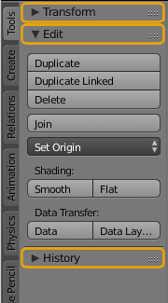
The smallest organizational unit in the user interface is a panel, which can be collapsed to hide its contents by clicking on its header. This is where the buttons, menus, checkboxes, etc. are located.
Panels are usually found in the side regions of an editor, but also make up most of the Properties Editor‘s main region.
In the image on the right there are 3 panels: Transfor*, Edit and History. The edit panel is expanded and the other 2 panels are collapsed. Note that you can change the order of panels by clicking on the handle in the upper right corner of a panel’s title.
See: panels for details.

Tabs
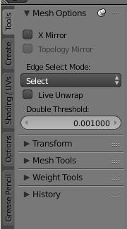
The Toolshelf has been further structured into a set of context sensitive vertical tabs.
In the image to the right you can see the tabs: Tools, Create, etc. The Tools tab is currently selected, showing a set of panels containing various tools.

Pinning
Often it is desirable to view panels from different tabs at the same time. This has been solved by making panels pinnable.
A pinned panel remains visible regardless of which tab has been selected. You can pin a panel by Shift clicking its header, or by right clicking on the header and choosing Pin.
Shown in the image above is an example of the Mesh Options pinned in the tools tab.

Input Devices

Bforartists supports various types of input devices:
- Keyboard (recommended: keyboard with numeric keypad, english layout works best)
- Mouse (recommended: 3 button mouse with scroll wheel)
- NDOF Devices (also known as 3D Mouse)
- Graphic Tablets

Usage of Mouse Buttons
In Bforartists the LMB (Left Mouse Button) is used for Selection and the LMB also (Left Mouse Button) initiates or confirms actions. Bforartists is not longer bound to the old Blender dogma of Action and Select mouse.

Non English Keyboard
If you use a keyboard with a non-english keyboard layout, you may stumble across bugs and quirks and odd behaviours. Blender was developed for and with the UK or US layout. Some quirks for other keyboard layouts slipped through. And quite a few of those old bugs are still unfixed in Bforartists too.
Bforartists corrects Gamma by default
Note
You can change the default keymap and default hotkeys from the User Preferences, however this manual assumes you are using the default keymap.

The Window System

The default scene
The default scene is separated into five windows and is loaded each time you start Bforartists or a new file. The five areas are:
- The Info Space (shaded red) at the top. (The Info window used mainly for its header).
- A large 3D View (shaded green).
- A Timeline at the bottom (shaded purple).
- An Outliner at the top right (shaded yellow).
- A Properties editor at the bottom right (shaded blue).
As an introduction we will cover a few of the basic elements.
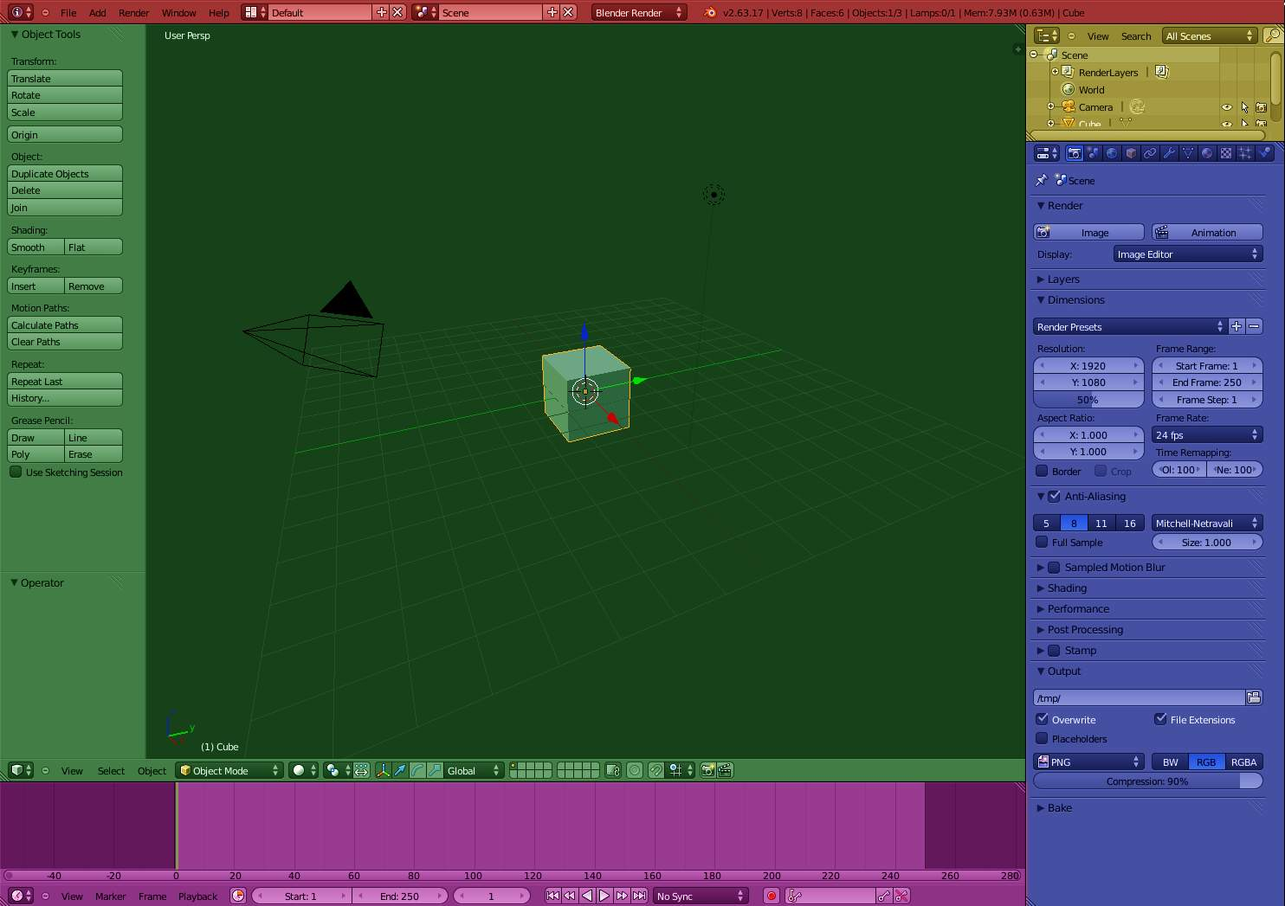
Default Bforartists scene and Window arrangement

Arranging Areas

Bforartists uses a novel screen-splitting approach to arrange areas. The application window is always a rectangle on your desktop. It divides it up into a number of re-sizable areas. An area contains the workspace for a particular type of window, like a 3D View window, or an Outliner. The idea is that you split up that big application window into any number of smaller (but still rectangular) non-overlapping area. That way, each window is always fully visible, and it is very easy to work in one window and hop over to work in another.

Maximizing an Area
You can maximize an area to fill the whole application window with the View –> Toggle Full Screen menu entry. To return to normal size, use again View –> Toggle Full Screen. A quicker way to achieve this is to use the corresponding hotkeys that gets displayed besides . NOTE: The window your mouse is currently hovering over is the one that will be maximized using the keyboard shortcuts.

Splitting an Area
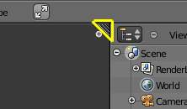
In the upper right and lower left corners of a window are the window splitter widgets, and they look like a little ridged thumb grip. It both splits and combines window panes. When you hover over it, your cursor will change to a cross. LMB and drag it to the left to split the window pane vertically, or downward to split it horizontally.

Joining Two Areas
In order to merge two areas, they must be the same dimension in the direction you wish to merge. For example, if you want to combine two areas that are side-by-side, they must be the same height. If the one on the left is not the same as the one on the right, you will not be able to combine them horizontally. This is so that the combined window space results in a rectangle. The same rule holds for joining two areas that are stacked on top of one another; they must both have the same width. If the one above is split vertically, you must first merge those two, and then join the bottom one up to the upper one.
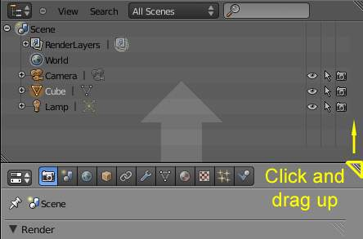
To merge the current window with the one above it (in the picture the properties window is being merged “over” the Outliner), hover the mouse pointer over the window splitter. When the pointer changes to a cross, LMB click and drag up to begin the process of combining. The upper window will get a little darker, overlaid with an arrow pointing up. This indicates that the lower (current) area will “take over” that darkened area space. Let go of the LMB to merge. If you want the reverse to occur, move your mouse cursor back into the original (lower) area, and it will instead get the arrow overlay.
In the same way, windows may be merged left to right or vice versa.
If you press Esc before releasing the mouse, the operation will be aborted.

Changing Area Size
You can resize areas by dragging their borders with LMB. Simply move your mouse cursor over the border between two areas until it changes to a double-headed arrow, and then click and drag.

Swapping Contents
You can swap the contents between two areas with Ctrl-LMB on one of the splitters of the initial area, dragging towards the target area, and releasing the mouse there. The two areas don’t need to be side by side, though they must be inside the same window.

Opening New Windows
You may wish to have a new window. This can be useful, for instance, if you have multiple monitors and want them to show different information on the same instance of Bforartists.
A new window can be created from Window ‣ Duplicate Window.
You can also create a new window from an existing area by Shift-LMB on a area splitter, and dragging slightly. A new window pops up, with its maximize, minimize, close and other buttons (depending on your platform), containing a single area with a duplicate of the initial window on which you performed the operation.
Once you have that new window, you can move it to the other monitor (or leave it in the current one); you can resize it (or keep it unchanged); you can also arrange its contents in the same way discussed so far (split and resize areas, and tune them as needed), and so on.

Window Headers

All windows have a header (the strip with a lighter gray background containing icon buttons). We will also refer to the header as the window ToolBar. The header may be at the top (as with the Properties Window) or the bottom (as with the 3D Window) of a window’s area. The picture below shows the header of the 3D window:
If you move the mouse over a window, its header changes to a slightly lighter shade of gray. This means that it is “focused”. All hotkeys you press will now affect the contents of this window.

Hiding a header
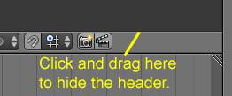
To hide a header, move your mouse over the thin line between a window and its header, until the pointer takes the form of an up/down arrow. Then click, hold and drag with LMB from the window over the header to hide the latter.

Showing a header
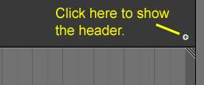
A hidden header leaves a little plus sign (see picture). By LMB this, the header will reappear.
Note 1: In the 3D window, there are up to two more of these little plus signs (to the top left and right of the window). Those will open panels with several tools, not a second header.
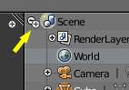
Note 2: In some windows, the mentioned plus sign can be hard to find, because it might look like a part of other icons. One example is the Outliner, in which there are other such plus signs, thus giving the one to get the header back good camouflage.

Header position
To move a header from top to bottom or the other way round, simply RMB on it and select the appropriate item from the pop-up menu. If the header is at the top, the item text will read “Flip to Bottom”, and if the header is at the bottom the item text will read “Flip to Top”.
Tip
Theme colors
Bforartists allows for most of its interface color settings to be changed to suit the needs of the user. If you find that the colors you see on screen do not match those mentioned in the Manual then it could be that your default theme has been altered. Creating a new theme or selecting/altering a pre-existing one can be done by selecting the User Preferences window and clicking on the Themes tab of the window.

Window type button
LMB clicking on the first icon at the left side of a header allows changing the window type. Every window frame in Bforartists may contain any type of window, allowing you to customize your window layout to your own work flows.

Menus and buttons
Most Window Headers, located immediately next to this first “Window Type” Menu button, exhibit a set of menus which can be hidden - again with a little minus sign. So if you cannot find a menu that was mentioned somewhere, try looking for a little plus sign (once again) next to the “Window Type” button. By clicking LMB on it, the menu will come back.
Menus allow you to directly access many features and commands, so just look through them to see what’s there. All Menu entries show the relevant shortcut keys, if any.
Menus and buttons will change with Window Type and the selected object and mode. They only show the actions that can be performed.

Collapsing Menus
Sometimes its helpful to gain some extra horizontal space in the header by collapsing menus, this can be accessed from the header context menu, simply right click on the header and enable set it to collapsed.
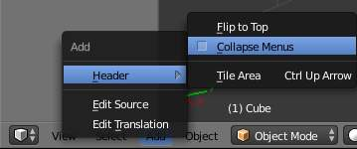
Right-click on any of the header menus Header ‣ Collapse Menus.
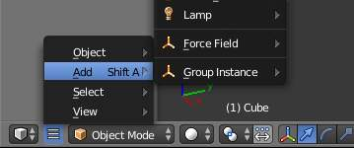
Access the menu from the collapsed icon.

Hiding the editor type menu
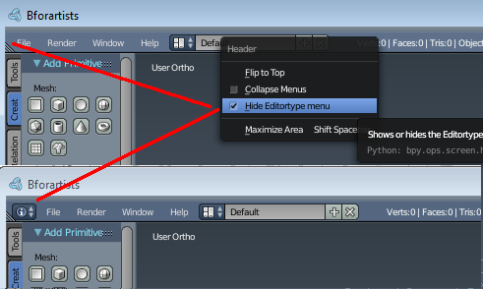
In Bforartists it is possible to hide the editor type menu. And it is in fact hidden for most editors in the standard layout.
Right click at the menu bar. And you will see a menu with the menu entry Hide Editortype Menu. This shows or hides the editor type menu.

The Console Window

The Console Window is an operating system text window that displays messages about Bforartists operations, status, and internal errors.
Use Cases:
- If Bforartists exits unexpectedly, the messages may indicate the cause or error.
- To see the output of Python scripts print() command.
- To launch with Command Line Arguments options.
- When troubleshooting, to see the output of --debug messages.

Platform Dependant Instructions

Linux
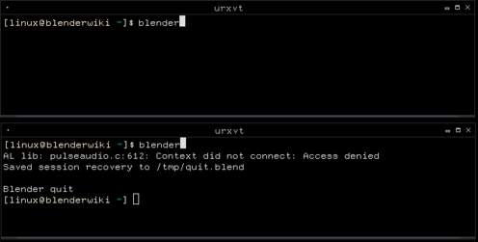
Starting Bforartists from a Linux console window.
The Bforartists Console Window in Linux will typically only be visible on the desktop if Bforartists is manually started from a terminal, as Bforartists outputs to the Console Window it is started from.
Depending on your desktop environment setup, a Bforartists icon may appear on your desktop or an entry for Bforartists added to your menu after you install Bforartists. When you start Bforartists using a desktop icon or menu entry rather than a Terminal window, the Bforartists Console Window text will most likely be hidden on the Terminal that your XWindows server was started from.
This screenshot shows Bforartists started from a Linux Terminal and the resulting console text being printed to it.

Mac OSX
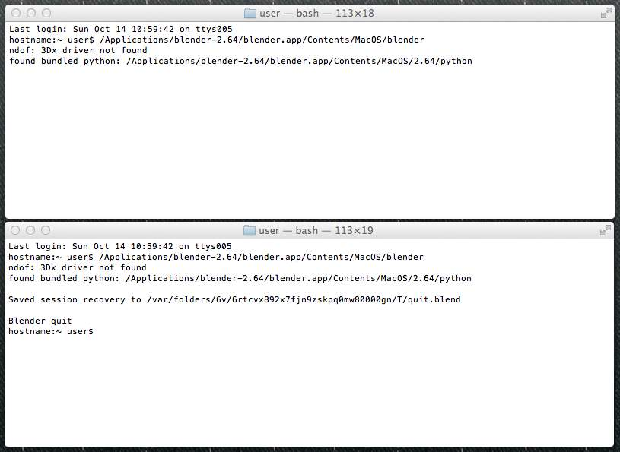
Starting Bforartists from a Mac OSX console window.
Mac-OSX uses “files” with the .app extension called applications. These files are actually folders that appear as files in Finder. In order to run Bforartists you will have to specify that path to the Bforartists executable inside this folder, to get all output printed to the terminal. You can start a terminal from Applications –> Utilities. The path to the executable in the .app folder is ./Bforartists.app/Contents/MacOS/Bforartists.
If you have Bforartists installed in the Applications folder, the following command can be used:
/Applications/Bforartists-2.76/Bforartists.app/Contents/MacOS/Bforartists

MS-Windows
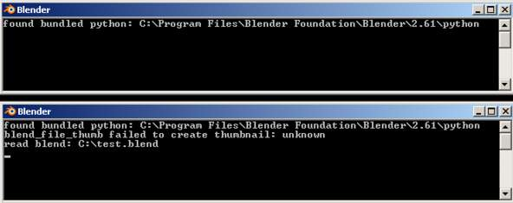
Bforartists’s Console Window on MS-Windows.
When Bforartists is started on a MS-Windows operating system, the Console Window is first created as a separate window on the desktop. The main Bforartists window will also appear and the Console Window will then be toggled off. To display the console again, go to Window ‣ Toggle System Console.
The screenshot shows the Bforartists Console Window on MS-Windows directly after starting Bforartists and then a short while later after opening a file along with the relevant messages.
Tip
Closing the Bforartists Console Window
Closing the Console Window will also close Bforartists, losing any unsaved work.
To turn off the console without closing Bforartists, just run Toggle System Console again from the menu (as mentioned above).

Console Window Status and Error Messages
The Bforartists Console Window can display many different types of Status and Error Messages. Some messages simply inform the user what Bforartists is doing, but have no real impact on Bforartists’s ability to function. Other messages can indicate serious errors that will most likely prevent Bforartists carrying out a particular task and may even make Bforartists non-responsive or shut down completely. The Bforartists Console Window messages can also originate internally from within the Bforartists code or from external sources such as Python scripts.

Common messages
- found bundled python: (FOLDER)
This message indicates that Bforartists was able to find the Python library for the Python interpreter embedded within Bforartists. If this folder is missing or unable to be found, it is likely that an error will occur, and this message will not appear.
- malloc returns nil()
When Bforartists carries out operations that require extra memory (RAM), it calls a function called malloc (short for memory allocate) which tries to allocate a requested amount of memory for Bforartists. If this cannot be satisfied, malloc will return nil/null/0 to indicate that it failed to carry out the request. If this happens Bforartists will not be able to carry out the operation requested by the user. This will most likely result in Bforartists operating very slowly or shutting down. If you want to avoid running out of memory you can install more memory in your system, reduce the amount of detail in your Bforartists models, or shut down other programs and services which may be taking up memory that Bforartists could use.

Screens

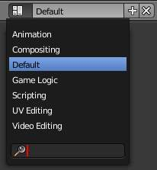
Layout Dropdown
Bforartists’s flexibility with windows lets you create customized working environments for different tasks such as modeling, animating, and scripting. It is often useful to quickly switch between different environments within the same file.
To do each of these major creative steps, Bforartists has a set of pre-defined screens, that show you the types of windows you need to get the job done quickly and efficiently. Screens are essentially pre-defined window layouts. If you are having trouble finding a particular screen, you can use the search function at the bottom of the list (pictured right).
Default Screens available
3D View Full: | A full screen 3D view, used to preview your scene.
Animation: | Making actors and other objects move about, change shape or color, etc.
Compositing: | Combining different parts of a scene (e.g. background, actors, special effects) and filter them (e.g. color correction).
Default: | The default layout used by Bforartists for new files. Useful for modeling new objects.
Motion Tracking: | Used for motion tracking with the movie clip editor.
Scripting: | Documenting your work and/or writing custom scripts to automate Bforartists.
UV Editing: | Flattening a projection of an object mesh in 2D to control how a texture maps to the surface.

Hint
Just important when you work with more than one scene at once:
By default, each screen layout ‘remembers’ the last scene it was used on. Selecting a different layout will switch to the layout and jump to that scene.
All changes to windows, as described in Editor Types, are saved within one screen. Changes to one screen, wont affect others.

Configuring your Screens

Adding a new Screen Type
Click on the “Add” button() and a new frame layout will be created based on your current layout.

Deleting a Screen
You can delete a screen by using the Delete Data-Block button (). See Screen and Scene selectors above.

Rearranging a Screen
Use the window controls to move frame borders, split and consolidate windows. When you have a layout that you like, press Ctrl-U to update your User defaults. Be aware that all of the current scenes become part of those defaults, so consider customizing your layouts with only a single, simple scene.
The properties window has a special option: pressing RMB on its background will allow you to arrange its panels horizontally or vertically. Of the two, vertically-arranged panels have greater support.

Overriding Defaults
When you save a .blend file, the screen layouts are also saved in it. When you open a file, enabling the Load UI checkbox in the file browser indicates that Bforartists should use the file’s screen layouts (overriding your defaults in the process). Leaving the Load UI checkbox disabled tells Bforartists to use the current layout.

Additional Layouts
As you become more experienced with Bforartists, consider adding some other screen layouts to suit your workflow as this will help increase your productivity. Some examples could include:
Modeling
Four 3D windows (top, front, side and perspective), Properties window for Editing
Lighting
3D windows for moving lights, UV/Image Window for displaying Render Result, Properties window for rendering and lamp properties and controls
Materials
Properties window for Material settings, 3D window for selecting objects, Outliner, Library script (if used), Node Editor (if using Node based materials)
Painting
UV/Image Editor for texture painting image, 3D window for painting directly on object in UV Face Select mode, three mini-3D windows down the side that have background reference pictures set to full strength, Properties window
Hint
Reuse your Layouts
If you create a new window layout and would like to use it for future .blend files, you can save it for later reuse, see Startup File.

Blender 2.76 Reference Manual - © Copyright : This page is in public domain as CC0.

Panels

Panels are collapsible sections within regions to help organize the interface. They are heavily used in the Properties Editor but also appear elsewhere (For example: in the Tool Shelf or the Properties Shelf, available in some editors).
The image below shows panels in different regions in their expanded and collapsed state.
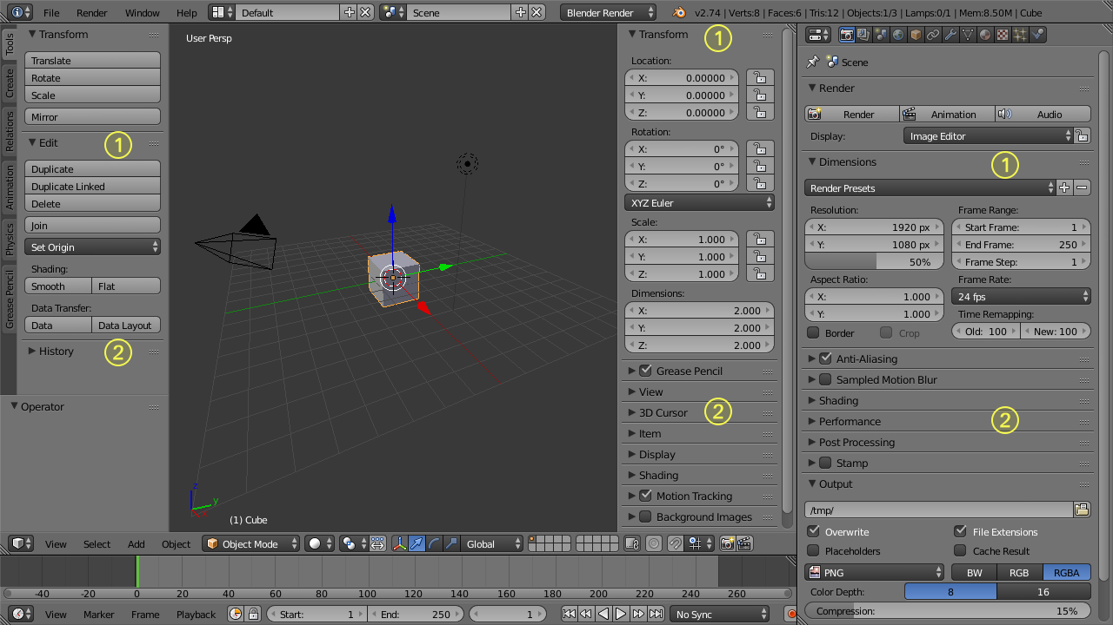
Expanded (1) and collapsed (2) Panels in the Properties Editor (right area) and in the additional Regions of the 3D View Editor (left area)
- A click with the LMB on the title area of a panel expands or collapses it.
- A LMB drag motion over the title area will expand or collapse many at once.
- A Ctrl-LMB click on the title area of a specific panel will collapse all other panels and make this the only expanded one.
Some panels only show in certain contexts. So for instance the Tool Shelf will show different panels depending on the objects mode.
There are some options available to customize panels to your preference:
- You can change the position of a panel within its region by clicking and dragging it with the LMB on the little widget in the upper right corner.
- The zoom factor of a whole region with panels can be changed by Ctrl-MMB clicking and moving the mouse anywhere within that region or use the NumpadPlus and NumpadMinus to zoom in and out the contents. Pressing Home (Show All) will reset the zooming at the screen/panel focused by the mouse pointer.
- The alignment of the panels in the Properties Editor can be changed between vertical and horizontal. To do this click with RMB somewhere within the main region of the Properties Editor and choose either Horizontal or Vertical from the appearing menu. Keep in mind though that the panels are optimized for vertical alignment.

Buttons and Controls

Buttons and other controls can be found in almost every Window of the Blender interface. The different types of controls are described below.

Operation Buttons
Operation button
These are buttons that perform an operation when clicked with LMB. They can be identified by their gray color in the default color scheme.

Toggle Buttons
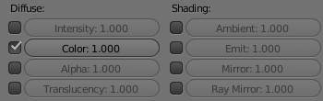
Toggle buttons
Toggle buttons are typically displayed as check boxes. Clicking this type of button will toggle a state but will not perform any operation.

Toggle Drag
To change many toggle buttons at once, you can LMB drag over multiple buttons, This works for check-boxes, toggles in the outliner and layer buttons.
Note
For layer buttons (a type of toggle button) it is often useful to hold Shift at the same time, to set or clear many layers at once.

Radio Buttons
Radio buttons
Radio buttons are used to choose from a small selection of “mutually exclusive” options.

Number Buttons
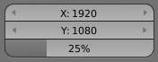
Number buttons
Number buttons can be identified by their labels, which in most cases contains the name and a colon followed by a number. Number buttons can be edited in several ways:
Incremental Steps
To change the value in steps, click LMB on the small triangles on the sides of the button.
Dragging
To change the value in a wider range, hold down LMB and drag the mouse to the left or right.
Text Input
Press LMB or Return to edit the value as a text field.
When entering values by hand, this button works like any other text button.
- Press Return to apply the change.
- Press Esc will cancel the value.

Multi-Value Editing
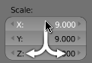
Multi-value-editing
It’s often useful to edit multiple values at once (object scale or render resolution for example).
This can be done by clicking on the button and dragging vertically to include buttons above/below.
After the vertical motion you can drag from side to side, or release the LMB to type in a value.

Expressions
You can also enter expressions such as 3*2 instead of 6. or 5/10+3. Even constants like pi (3.142) or functions like sqrt(2) (square root of 2) may be used.
These expressions are evaluated by Python; for all available math expressions see: math module reference

Expressions as Drivers
You may want your expression to be re-evaluated after its entered. Blender supports this using Drivers (a feature of the animation system).
Expression beginning with #, have a special use. Instead of evaluating the value and discarding the expression, a driver is added to the property with the expression entered.
The expression #frame is a quick way to access map a value to the current frame, but more complex expressions are also supported #fmod(frame, 24) / 24 for example.
This is simply a convenient shortcut to add drivers which can also be added via the RMB menu.

Units
As well as expressions, you can mix units with numbers; for this to work, units need to be set in the scene settings (Metric or Imperial).
Examples of valid units include:
- 1cm  - 1m 3mm  - 1m, 3mm | - 2ft  - 3ft/0.5km  - 2.2mm + 5' / 3" - 2yards
Note that the commas are optional. Notice how you can mix between metric and imperial even though the display can only show one at a time.

Unit Names
Unit names have can be used with both long and short forms, here are listed recognized unit names you can use.
Plurals of the names are recognized too, so meter and meters can both be used.

Imperial Units
Full Name | Short Name(s) | Scale of a Meter
thou | mil | 0.0000254
inch | ", in | 0.0254
foot, feet | ', ft | 0.3048
yard | yd | 0.9144
chain | ch | 20.1168
furlong | fur | 201.168
mile | mi, m | 1609.344

Metric Units
Full Name | Short Name(s) | Scale of a Meter
micrometer | um | 0.000001
millimeter | mm | 0.001
centimeter | cm | 0.01
decimeter | dm | 0.1
meter | m | 1.0
dekameter | dam | 10.0
hectometer | hm | 100.0
kilometer | km | 1000.0

Menu Buttons
Blender uses a variety of different menus for accessing options, tools and selecting data-blocks.

Menu Shortcuts
- Arrow keys can be used to navigate.
- Each menu item has an underlined character which can be pressed to activate it.
- Number keys or num-pad can be used to access menu items. (Where 1 is the first menu item, 2 the second... etc. For larger menus Alt-1 the 11th... up to Alt-0 the 20th)
- Press Return to activate the selected menu item.
- Press Esc to cancel the menu.

Header Menus
Header menus are used to configure the editor and access tools.
See Headers for header options.

Pop-Up Menus
Pop-up menus are displayed as regular buttons, showing a range of options. For example, the Add Modifier button will produce a menu with all of the available modifiers.
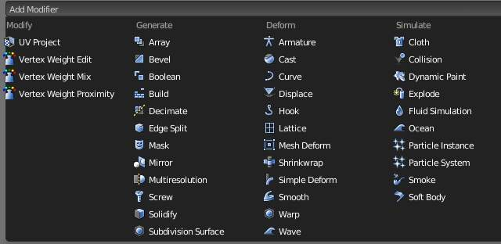
Modifier options

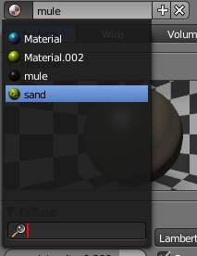
Data-Block Menus
Menu buttons are used link data-blocks to each other. data-blocks are items like Meshes, Objects, Materials, Textures, and so on.
These menu’s may show a preview and allow you to search by name since its common all items wont fit in the list.

Data-block link menu with search
- The first button (with an icon of the data-block type) opens up a menu to select an item by clicking LMB.
- The second button displays the name of the linked data-block which can be edited as a regular text field.
- The “+” button duplicates the current data-block and applies it.
- The “X” button clears the link.
Sometimes there is a list of applied data-blocks (such as a list of materials used on the object). See data-block link buttons above.
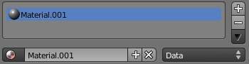
Data-block link buttons
- To select a data-block, click LMB on it.
- To add a new section (e.g. material, or particle system), click LMB on the “+” button to the right of the list.
- To remove a section, click LMB on the “-” to the right of the list.
For details on the behavior of linking data see data-block.

Extended Controls

This page documents some of the more involved interface controls.
Operator Search Menu
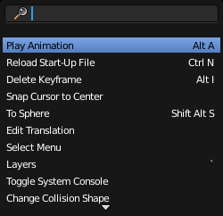
The operator search popup.
A menu with access to all Blender commands is available in the Window menu at the top, or by pressing Spacebar. Simply start typing the name of the command you want to refine the list. When the list is sufficiently narrowed, LMB on the desired command or navigate with Down and Up, activate it by pressing Return.

Color Picker
All of the Color picker types have the common RGB, HSV and Hex options to show values.
Blender uses 0 - 1.0 values to express colors for RGB and HSV values.
Some colors also define an alpha value (A), below the color sliders.
Note
Blender corrects Gamma by default
for more information about how to disable Gamma correction in Blender, see: Color Management and Exposure page.

- Use Wheel to change overall brightness.
- Press Backspace to reset to the original color.

Color Picker Types
The default color picker type can be selected in the user preferences, see: System.
For operations that are capable of using Alpha, another slider is added at the bottom of the color picker.
- 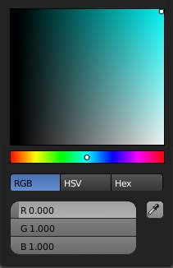  Square (SV + H), Saturation, Value plus Hue. Colors are adjusted using the a range of brightness of the base color chosen at the color bar in the middle of the picker.  - 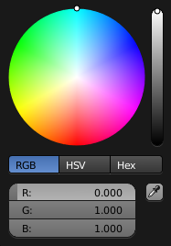  Circle HSV (Default). A full gamut of colors ranging from center to the borders is always shown; center is a mix of the colors. | - 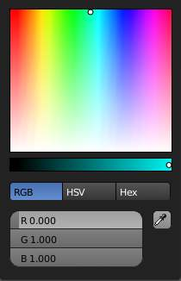  Square (HS + V), Hue, Saturation plus Value. Brightness is subtracted from the base color chosen on the square of the color picker moving the slider to the left.  - 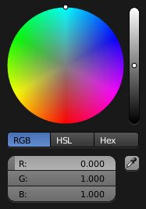  Circle HSL. A variation of the regular circle select that uses HSL for mixing. | - 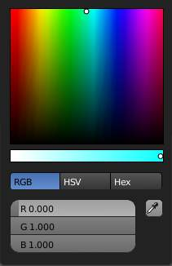  Square (HV + S), Hue, Value and Saturation. Brightness is added to the base color chosen on the square of the color picker moving the slider to the left.

Hexidecimal Colors
You can optionally use hexidecimal (Hex) values, expressed as (RRGGBB), a common way to represent colors for HTML and useful quicky copy/paste colors between applications.
Shorthand hex colors are also supported (RGB), so dark-yellow (ffcc00), can be written as fc0.

Eye Dropper
The eye dropper allows you to sample from anywhere in the Blender window.
The eyedropper can be use to select different kinds of data.
Color
This is the most common usage.
Objects / Object-Data
This is used with object buttons such as parent, constraints or modifiers to select an object from the 3D view.
Camera Depth
Number buttons effecting distance can also use the eye-dropper, this is most useful for camera depth of field.
- E will activate the eye-dropper while hovering over a button.
- LMB dragging will mix the colors you drag over which can help when sampling noisy imagery.
- Spacebar resets and starts mixing the colors again.

Color Ramp Widget
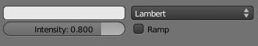  Colorband before | 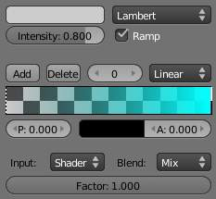  Colorband after
Color Ramps enables the user to specify a range of colors based on color stops. Color stops are similar to a mark indicating where the exact chosen color should be. The interval from each of the color stops added to the ramp is a result of the color interpolation and chosen interpolation method. The available options for Color Ramps are:
Add (Button)
Clicking on this button will add a stop to your custom weight paint map. The stops are added from the last selected stop to the next one, from left to right and they will be placed in the middle of both stops.
Delete (Button)
Deletes the selected color stop from the list.
‘F’ (Button)
Flips the color band, inverting the values of the custom weight paint range.
Numeric Field
Whenever the user adds a color stop to the custom weight paint range, the color stop will receive an index. This field shows the indexes added (clicking in the arrows until the counter stops), and allows the user to select the color stop from the list. The selected color stop will be shown with a dashed line.
Interpolation Options
Enables the user to choose from 4 types of calculations for the color interpolation for each color stop. Available options are:
B-Spline
Uses a B-Spline Interpolation for the color stops.
Cardinal
Uses a Cardinal Interpolation for the color stops.
Linear
Uses a Linear Interpolation for the color stops.
Ease
Uses a Ease Interpolation for the color stops.
Constant
Uses a Constant Interpolation for the color stops.
Position
This slider controls the positioning of the selected color stop in the range.
Color Bar
Opens a color Picker for the user to specify color and Alpha for the selected color stop. When a color is using Alpha, the Color Bar is then divided in two, with the left side showing the base color and the right side showing the color with the alpha value.

Curve Widget
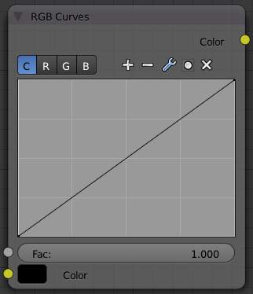
The Curve Widget is found in several places throughout Blender, such as:
- RGB Curves node
- Vector Curves node
- Paint/Sculpt brush falloff
- Color Management curves
The purpose of the Curve Widget is to allow the user to modify an input (such as an image) in an intuitive manner by smoothly adjusting the values up and down using the curve.
The input values are mapped to the X-axis of the graph, and the Y-axis is mapped to the output values.

Control Points
Like all curves in Blender, the curve of the Curve Widget is controlled using control points.
By default there are two control points: one at 0.0, 0.0 and one at 1.0, 1.0, meaning the input is mapped directly to the output (unchanged).
To move a control point
Simply click and drag it around.
To add a new control point
Click anywhere on the curve where there is not already a control point.
To remove a control point
select it and click the button at the top right.

Controls
Above the curve graph is a row of controls. These are:
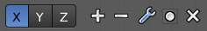
Node curve controls
Channel selector
Allows to select appropriate curve channel.
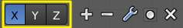
Curve channel selector
Zoom In
Zoom into the center of the graph to show more details and provide more accurate control. To navigate around the curve while zoomed in, click and drag in an empty part of the graph.
Zoom Out
Zoom out of the graph to show less details and view the graph as a whole. You cannot zoom out further than the clipping borders (see Clipping below).
Tools
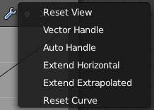
Advanced tools for curve
Reset View
Resets view of the curve.
Vector Handle
Vector type of curve point’s handle.
Auto Handle
Automatic type of curve point’s handle.
Extend Horizontal
Extends the curve horizontal.
Extend Extrapolated
Extends the curve extrapolated.
Reset Curve
Resets the curve in default (removes all added curve’s points).
Clipping
Enable/disable clipping and set the values to clip to.
Delete
Remove the selected control point.

List View
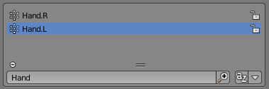
At the bottom of a list view (like the ones found in the object data properties) there are controls for filtering and sorting and resizing.
Rename
By pressing (Ctrl, LMB) over an item’s name, you can edit the text-field. This can also be achieved by double clicking.
Resize
The list view can be resized to show more or less items. Hover the mouse over the handle then click and drag the handle to expand or shrink the list.
Filter
Click the Show filtering options button to toggle filter option buttons.
Type part of a list item’s name in the filter text box to filter items by part of their name.
Filter Include
When the magnifying glass icon has a + sign then only items that match the text will be displayed.
Filter Exclude
When the magnifying glass icon has a - sign then only items that do not match text will be displayed.
Sort
Sort list items.
Alphabetical
This button switches between alphabetical and non-alphabetical ordering.
Inverse
Sort objects in ascending or descending order. This also applies to alphabetical sorting, if selected.

Copy / Paste

Reference
Mode: All modes
Hotkeys: ctrl + c to copy, ctrl + v to paste
Copy and paste works like in many other applications too. And works in most editors. The menu entry is usual located in the menu bar as a menu item in the menus. And it's one of those things in Bforartists that has a standard hotkey.

Copy and paste in Edit mode has a special behaviour. It copies the current selection. But it does not paste the selection in Edit mode. But it pastes the selection as a new object.

To create a copy of the current selection in Edit mode, which is part of the current object, is a job for the duplicate tool.

Undo and Redo

The commands listed below will let you roll back an accidental action, redo your last action, or let you choose to recover to a specific point, by picking from a list of recent actions recorded by Blender.

Undo
If you want to undo your last action, just press Ctrl-Z. Or click at the Undo button in the History section in the Tool Shelf. See Editing Preferences section on undo to change defaults.

Redo
To roll back your Undo action, press Ctrl-Shift-ZOr click at the Undo button in the History section in the Tool Shelf.

Redo Last
Redo Last is short for Redo(ing your) Last (Action). The operator area in the Tool Shelf will present you a Panel based on your last action taken and the Mode and Window in which Blender is being used.
For example, if your last action was a rotation in Object Mode, the Panel will show you the last value changed for the angle (see Fig:Redo Last - Rotation), where you can change your action back completely by typing 0 (zero) in the numeric field. There are other useful options, based on your action context, and you can not only Undo actions, but change them completely using the available options.
If you are in Edit Mode, the Window will also change its contents based on your last action taken. In our second example (at the right), the last action taken was a Vertex Move; we did a Scale on a Face, and, as you can see, the contents of the Pop-Up Window are different, because of your context (Edit Mode).
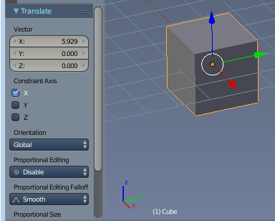

Tip
Operations using Redo Last
Some operations produce particularly useful results if you tweak their parameters with the F6 Menu. Take, for example, adding a Circle. If you reduce the Vertex count to 3, you get a perfect equilateral triangle.

Undo History
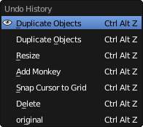
The Undo History Menu
There is also a Undo History of your actions, recorded by Blender. You can access the history with Ctrl-Alt-Z. Or by clicking at the Undo History button in the History section of the Tool Shelf
Rolling back actions using the Undo History feature will take you back to the action you choose. Much like how you can alternate between going backward in time with Ctrl-Z and then forward with Ctrl-Shift-Z, you can hop around on the Undo timeline as much as you want as long as you do not make a new change. Once you do make a new change, the Undo History is truncated at that point.

Repeat Last
The Repeat Last feature will Repeat your last action when you press Shift-R. Or by clicking at the Repeat History button in the History section of the Tool Shelf
In the example Images below, we duplicated a Monkey Mesh, and then we moved the Object a bit. Using repeat Shift-R, the Monkey was also duplicated and moved.
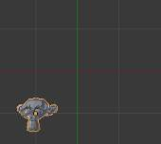  Suzanne. | 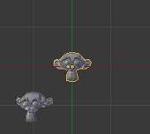  After a Shift-D and move. | 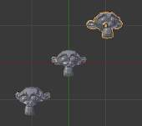  After a Shift-R.

Repeat History
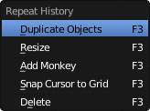
The Repeat Menu
The Repeat History feature will present you a list of the last repeated actions, and you can choose the actions you want to repeat. It works in the same way as the Undo History, explained above, but the list contains only repeated actions. To access Repeat History, use F3. Or by clicking at the Repeat History button in the History section of the Tool Shelf

Note
Blender uses two separate Histories, one dedicated for the Edit Mode, and one dedicated for the Object Mode.

Important
When you quit Blender, the complete list of user actions will be lost, even if you save your file before quitting.

See also
Troubleshooting section on Recovering your lost work

Screen Capture

Screenshots
Reference
Mode: All modes
Menu: Window ‣ Save Screenshot

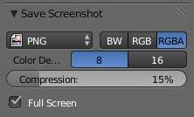
Save Screenshot Option
A click at the Save Screenshot Button in the Windows menu will take a screenshot of your Blender window and then open the Blender File Browser window, allowing you to specify the name and location of the screenshot. In the example image at the right, the PNG format will be the output of the screenshot taken (settings are the same as the ones available to save render results). When the Blender File Browser window opens for you, at the left, there is a tab called Save Screenshot where you can find format settings and a checkbox with the option Full Screen.
- Check the Option to save the entire Blender window (full width and height of the Blender window you are using when you call the command).
- Uncheck the box to save only your active window (where your mouse is located when you call the command).

Screencasts
Reference
Mode: All modes
Menu: Window ‣ Make Screencast

This is a quick way to make screen-casts from within Blender.
Note
This is limited to a single window and does not support audio.
For recording tutorials you may want to use more comprehensive, 3rd party solutions.

Screencasts will record your actions over time either as a video or sequence of image files. The type and location of the output is determined by the settings in the Output panel of the Render context window. The default settings will generate a screencast consisting of a series of PNG images captured every 50 ms and stored in the /tmp folder. If you want to record a video, set the Output to one of the Movie File Formats supported by your system listed in the Output panel format menu. If you are unsure what video codecs your system supports, select AVI JPEG.
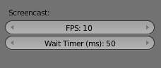
Options in the User Preferences Editor
The FPS for video Screencasts and time between each Screenshot for an image series Screencast can be set from the System panel of the User Preferences window.
When you start Blender Screencasts, the header of the Info Window will change, and it will show you a button for stopping your capture.
Below, we show the normal header of the Info Window, when in normal Blender operation (See Fig: Info Window - Header - Normal Operation), and with the Stop button for the Screencast, when in Screencast Mode. (See Fig: Info Window - Header - Capture Stop Button).
Info Window - Header - Normal Operation
Info Window - Header - Capture Stop Button
Note
The only way to stop the Screencast
Pressing the Stop button in the header of the Info Window is the only way to stop the Screencast capture. If you press Esc, the shortcut will only work for operations performed in the Blender User Interface, (it will stop animations, playbacks and so on...), but will not work to stop Screencasts.

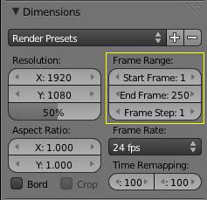
Dimensions Panel - Frame Range
The frames are stored using a suffix added to their file name, where the suffix is composed of the numbers present in the fields for start and end frames, defined in the Frame Range of the Dimensions panel, Render context. (See Fig: Dimensions Panel - Frame Range - highlighted in yellow)
Note
The configuration of the End frame, present in the Frame Range of the Dimensions Panel, will not stop your capture automatically. You will always have to stop the Screencast manually, using the Stop button.

The Videos are generated internally in the same manner as the Screenshots, using the width and height of the Window you are working in. If you choose to capture to a Video file, Blender will have to pass those frames to a Video codec.
Warning
Some codecs limit the output width/height or the video quality.
- When you save your Screencast in an Image format, the Images will be saved using the entire Blender Window, with full width and height, and the quality of the Image will be defined by its type (i.e. JPG, PNG, and so on) and configuration (i.e. Slider quality of the .JPG format).
- When you save your Screencast in a Video format, it will be sent to a codec. Depending on the codec limitations, the resulting output Video could be scaled down. Furthermore, some combinations of Window width and height cannot be processed by certain codecs. In these cases, the Screencast will try to start, but will immediately stop. In order to solve this, choose another Window format and/or another codec.

Blender Window Dimension
There is a way to match the Blender Window dimensions with the Output Video File, achieving standard dimensions for the output of the Blender Screencast. (I.e. NTSC, HD, Full HD, etc). You can control the width and height of your Blender Window, starting Blender from a Command Line. To learn more about starting Blender from a command line, see the page about Blender Console Window.

Ruler and Protractor

The ruler can be accessed from the toolshelf, once activated you can use the ruler to measure lengths and angles in the scene.
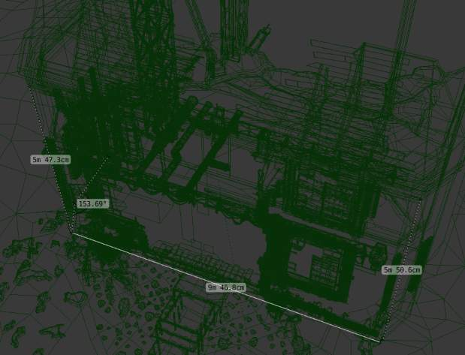
Example of the ruler and protractor.
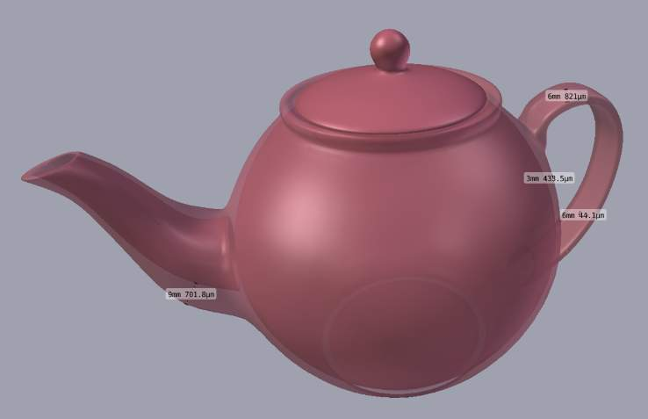
Example using the ruler to measure thickness.

Usage
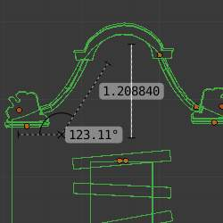
Here are common steps for using the ruler.
- Activate the Ruler from the toolshelf.
- Click and drag in the view-port to define the initial start/end point for the ruler.
- Orbit the view and click on either end of the ruler to re-position it. Holding Ctrl enables snap to elements.
- Click on the middle to measure angles.
- Press Return to store the ruler for later use or Esc to cancel.
Note
Editing operations can be used while the ruler is running, however tools like the knife can’t be used at the same time.

Note
Unit settings and scale from the scene are used for displaying dimensions.

